**Personal, Social Emotional Development**

* Children play co-operatively taking turns with others
* they take account of one another’s ideas about how to organise their activity
* they show sensitivity to other’s needs and feelings and form positive relationships with adults and other children.
* children are confident to try new activities and say why they like some activities more than others
* they are confident to speak to a familiar group, will talk about their ideas and will chose the resources they need for their chosen activity
* they say when they do or don’t need help.
* children talk about how they and others show feelings, talk about their own and others behaviour and its consequences and know that some behaviour is unacceptable
* they work as part of a group or class, and understand and follow the rules
* they adjust their behaviour to different situations, and take change of routine in their stride.

**Physical Development**

* children know the importance for good health of physical exercise and a healthy diet, and talk about the ways to keep healthy and safe
* they manage their own basic hygiene and personal needs successfully, including dressing and going to the toilet independently.
* children show good control and co-ordination in large and small movements
* they move confidently in a range of ways, safely negotiating space
* they handle equipment and tools effectively, including pencils for writing.

**Communication and Language**

* children listen attentively in a range of situations
* they listen to stories, accurately anticipating key events and respond to what they hear with relevant comments, questions or actions
* they give their attention to what others say and respond appropriately, while engaged in another activity
* children follow instructions involving several ideas or actions
* they answer how and why questions about their experiences and in response to stories or events
* children express themselves effectively showing awareness of listeners needs
* they use past, present and future forms accurately when talking about events that have happened or about to happen
* they develop their own narratives and explanations by connecting ideas or events.

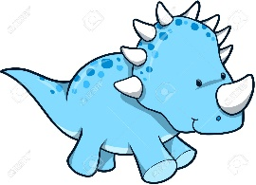

**SUMMER TWO**

**AMAZING ANIMALS**

**Literacy**

* Phonics Phases three and four
* children read and understand simple sentences
* they use phonic knowledge to decode regular words and read them aloud accurately
* they also read some common irregular words
* they demonstrate understanding when talking with others about what they have read.
* children use their phonic knowledge to write words which match their spoken sounds
* they also write some irregular common words
* they write simple sentences which can be read by themselves and others, some words are spelt correctly others are phonetically plausible.

**Maths**

* children use everyday language to talk about size, weight, capacity, position, distance, time and money to compare quantities and objects and to solve problems.
* they recognise, create and describe patterns
* they explore characteristics of everyday objects and shapes and use mathematical language to describe them.
* children count reliably with numbers from 1-20, place them in order and say which is 1 more or 1 less than a given number
* using quantities and objects, they add and subtract 2 single digit numbers and count on or back to find the answer
* they solve problems including doubling, halving and sharing.

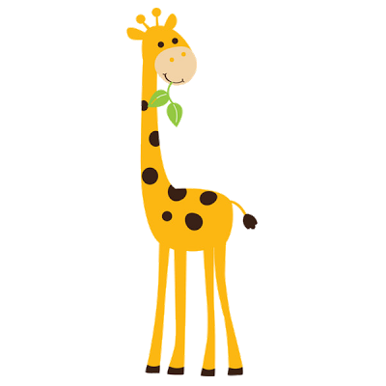

**Understanding of the World**

* children talk about past and present events in their own lives and lives of family members
* they know that other children don’t always enjoy the same things, and are sensitive to this
* they know about similarities and differences between themselves and others, and among families, communities and traditions
* children know about similarities and differences in relation to places, objects, materials and living things
* they talk about the features of their own immediate environment and how environments may vary from one another
* they make observations of animals and plants and explain why some things occur, and talk about changes
* children recognise that a range of technology is used in places such as homes and schools and they select and use technology for particular purposes.

**Expressive Art and Design**

* children sing songs, make music and dance and experiment with ways of changing them
* they safely use and explore a variety of materials, tools and techniques, experimenting with colour, design, texture, form and function
* children use what they have learnt about media and materials in original ways, thinking about uses and purposes
* they represent their own ideas, thoughts and feelings through design and technology, art, music, dance, role play and stories.

