**Personal, Social Emotional Development**

* to demonstrate friendly behaviour, initiating and forming good relationships with peers
* to initiate conversations, attends to and takes account of what others say
* to be able to take steps to resolve conflicts
* aware of own feelings and knows that some actions can hurt others
* to be able to accept the needs of others and can take turns and share resources, sometimes with support
* to be aware of the boundaries set, and of behavioural expectations
* to be more outgoing towards unfamiliar people and more confident in new situations
* to be confident to talk to other children when playing
* to be confident to speak to others about own wants, needs, interests and opinions

**Physical Development**

* to be able to dress with help
* to show understanding of how to transport and store equipment safely
* to be able to practice some appropriate safety measures
* to hold a pencil near point between 2 fingers and thumb and use it with good control
* to be able to travel with confidence and skill around, under, over and through balancing and climbing equipment
* to handle tools, objects, construction and malleable materials safely
* to form recognisable letters

**Communication and Language**

* to show an understanding of prepositions such as “under” “on top”
* to respond to instructions
* to listen and respond to ideas expressed by others
* to listen to others 1-1 or in small groups
* to maintain attention, concentrates and sits quietly during activity
* to have 2 channelled attention – can listen and do
* to use more complex sentences to link thoughts e.g. because
* to retell a simple past event in the correct order – how do things change?
* to extend vocabulary by naming, grouping, and exploring the meaning of new words

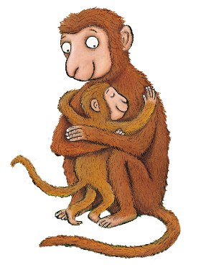

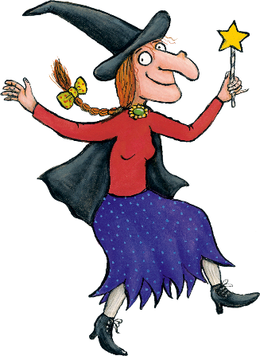

**Literacy**

* Phonics Phase Two
* to sometimes give marks as they draw and paint
* to segment the sounds in simple words and blend them together
* to link sounds to letters, naming and sounding the letters of the alphabet
* to use some clearly identifiable letters to communicate meaning representing some sounds correctly
* to describe main story events and settings
* to recognise familiar words and signs
* to know that print carries meaning and is read from l-r in English
* to hear and say the initial sound in words
* to segment the sounds in simple words and blend them
* to link sounds to letters, naming and sounding letters

**AUTUMN TWO**

**JULIA DONALDSON**

**Maths**

* to use positional language
* to use mathematical names and descriptions for solid and flat shapes
* to use familiar and common shapes to create patterns
* to use everyday language related to time – night time, day time
* to recite numbers in order to 10
* to sometimes match numeral and quantity correctly
* to count objects to 10 (1-1 correspondence)
* to select the correct numeral to represent 1-5 then 1-10 objects
* to find the total number of items in 2 groups by counting all of them

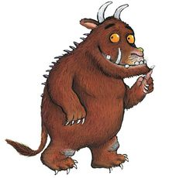

**Understanding of the World**

* to know how to operate simple equipment e.g. cd player
* show skill in making toys work by pressing parts or lifting flaps
* to use ICT hardware
* to comment and ask questions about aspects of their familiar world such as the place they live
* to talk about why things happen and how things work
* to look closely at similarities, difference, pattern and change
* to remember and talk about significant events in their own life
* to know some of the things that make them unique and to enjoy joining in with family customs

**Expressive Art and Design**

* to use available resources to create props to support role play
* to create simple representations of events, people and events
* to play co-operatively as part of a group to develop and act out a narrative
* to use various construction materials
* to begin a repertoire of songs and dances
* to explore the different sounds of instruments
* to explore what happens when they mix colours

