**Personal, Social Emotional Development**

* can play in a group, extending and elaborating play ideas
* initiates play, offering cues to pees to join them
* keeps play going by responding to what others are saying or doing
* demonstrates friendly behaviour, initiating conversations and forming good relationships with peers and familiar adults
* can select and use activities and resources with help
* welcomes and values praise for what they have done
* is more outgoing towards unfamiliar people and more confident in new social situations
* confident to talk to other children when playing, and will communicate freely about own home and community
* shows confidence in asking adults for help
* aware of own feelings, and knows that some actions and words can hurt others’ feelings
* begins to accept the needs of others and can take turns and share resources, sometimes with support from others
* can usually adapt behaviour to different events, social situations and changes in routines

**Physical Development**

* observes the effects of activity on their body
* understands that equipment and tools must be used safely
* can manage washing and drying hands
* moves clearly and with pleasure and confidence in a range of ways
* mount stairs, steps or climbing equipment using alternate feet
* walk downstairs, 2 feet to each step while carrying a small object
* runs skilfully and negotiates space successfully
* can stand momentarily on one foot
* can catch a large ball
* draws lines and circles using gross motor
* uses one handed tools and equipment
* holds pencil near point between first 2 fingers and thumb
* can copy some letters e.g. letters from their name

**Communication and Language**

* to listen to stories with increased attention and recall
* to join in with repeated refrains and anticipate key events and phrases in rhymes and stories
* focusing attention and is able to follow directions
* understands the use of objects, e.g. what do we use to cut things
* responds to simple instructions and is beginning to understand how and why questions and questions why things happen and gives explanations
* beginning to use more complex sentences to link thoughts e.g. because
* can retell a simple past event in the correct order and uses talk to connect ideas, explain what is happening and anticipate what might happen next
* use a ranges of tenses, intonation, rhythm and phrasing
* uses vocabulary focused on objects and people
* builds up vocabulary that reflects the breadth of their experiences

**Literacy**

* Phonics Phase One/Two
* sometimes gives meanings to marks as they draw
* ascribes meanings to marks they see in different places
* enjoy rhyming and rhythmic activities and shows awareness of rhyme and alliteration
* listen to and joins in with stories and poems and joins in with repeated refrains
* beginning to be aware of the way stories are structured and listens to stories with increasing attention, beginning to suggests how the story might end
* describes main story settings, events and characters and shows interest in illustration and print
* recognises familiar words and signs, looks at books independently and handles them with care
* knows information can be relayed in print and holds books the correct way up
* knows print carries meaning and in English is read left to right

**AUTUMN ONE**

**ALL ABOUT ME**

**Maths**

* shows an interest in shape and space by playing with shapes
* shows awareness of similarities of shapes in the environment and talks about shapes in the environment
* uses positional language
* shows interest in shape by sustained construction activity
* uses some number names and number language some accurately in their play
* recites numbers in order to 10 and shows curiosity about numbers
* knows that numbers identify how many objects are in a set
* beginning to represent numbers using fingers, marks on paper
* sometimes matches numerals and quantities
* compares 2 groups, saying when they have the same amount
* separates a group of 3 or 4 objects in different ways
* shows an interest in numerals in the environment and realises anything can be counted e.g. steps

**Understanding of the World**

* shows interest in the lives of people who are familiar to them
* remember and talks about significant events in their own experience
* recognises and describes special times or events and shows an interest in different occupations and ways of life
* knows about some of the things that make them unique
* comments and asks questions about aspects of their familiar world can talk about some of the things they have observed such as plants and animals
* talks about why things happen and how things work
* developing an understanding of growth, decay and changes and shows care and concern for living things
* knows how to operate simple equipment and shows an interest in technological toys
* shows skill in making toys work by pressing parts or lifting flaps
* knows that information can be retrieved from computers

**Expressive Art and Design**

* enjoys joining in with dancing and ring games
* sings a few familiar songs
* beginning to move rhythmically and imitates movement in response to music
* taps out simple repeated rhythms and explores how sounds can change
* explores colours and how colours can be changed
* understands that lines can be used to enclose a space
* uses various construction materials and starts to construct
* realises tools can be used for a purpose
* sings to self and makes up songs
* notices what adults do and starts to imitate them whilst engaging in imaginative play and builds stories around toys

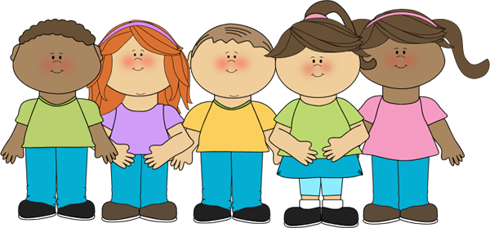

**Expressive Art and Design**